POLISH-AMERICAN ENGINEERS ASSOCIATION

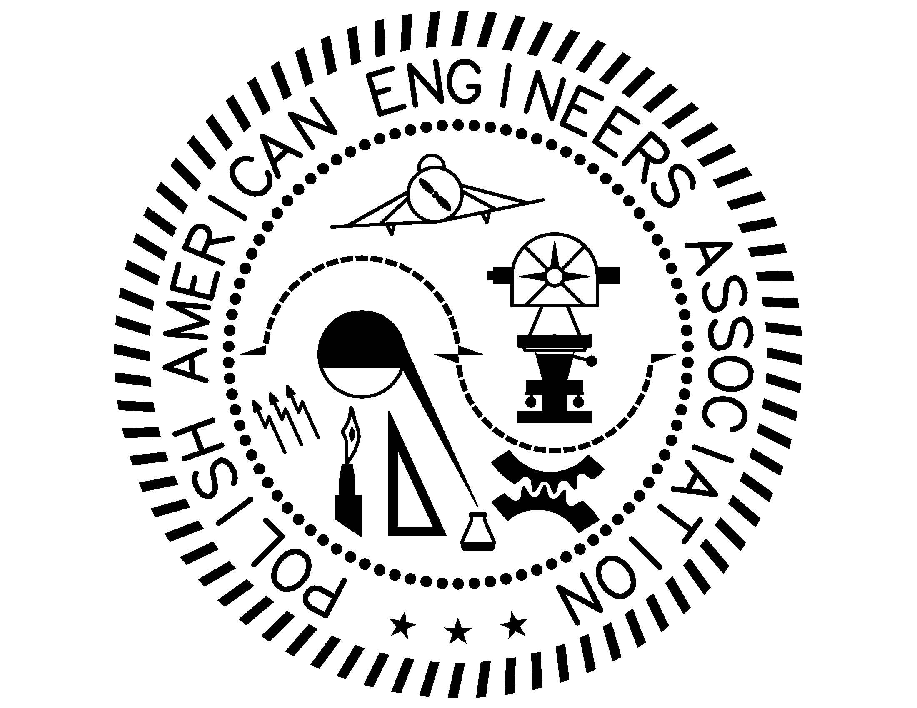

Founded
In 1934

1 Watergate Drive South Barrington Illinois 60010, USA ● www.polishengineers.org

All members and friends of Polish-American Engineers Association are cordially invited to attend our meeting.

DATE: Friday, November 20th 2015

TIME: 7:30 p.m.

PLACE: Copernicus Center
Kings Hall
5216 W. Lawrence Avenue
Chicago, Illinois

SPEAKER: Dr. Ferdinand Leya MD PhD
Professor of Medicine/Cardiology
Director, Cardiac Catheterization Lab
Director Interventional Cardiology

TOPIC: Abdominal Aortic Aneurysm

New EVAR Technologies

Coronary Artery Disease

Aortic Valve Disease

Mitra Clip

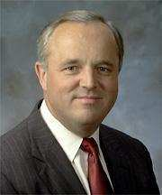
Dr. Fred Leya, MD PhD

Dr. Ferdinand Leya was born in Poland in 1952. He received his M.D. – graduating Summa Cum Laude – from the Jagiellonian University, Krakow, Poland. Presently, he is Professor of Medicine at Loyola University Medical Center, Director of the Cardiac Cath Lab, and Director of Interventional Cardiology. Since 1978, when he arrived in the U.S., Dr. Leya’s career has seen a quick succession of advances and achievements. He accepted a residency in internal medicine at Columbus Hospital in Chicago, and then between 1980 and 1981 he advanced to the position of Chief Resident in Internal Medicine and became Instructor in Medicine at Northwestern University Medical Center in Chicago. Between 1980 and 1983, Dr. Leya was granted a Fellowship in Cardiology from Loyola University Medical Center

Dr. Leya is considered an expert and one of the most experienced interventional cardiologists in the Chicago area having performed thousands of procedures. This vast experience led him to create numerous special programs at Loyola. In addition, he authored and co-authored over 75 publications, books and abstracts.

As a full-time faculty member of Loyola University Medical Center he actively participates in the teaching of medical students, residents and fellows who have a unique opportunity to be trained in state-of-the-art interventional cardiology.

In July 1995 and 2014 Chicago Magazine named him among the top interventional cardiologists in the Chicago Metropolitan area. In October 1997, he was presented the Polish American Congress “Heritage Award” in recognition of outstanding service and accomplishments in the field of modern medicine. In 2015 Castle Connolly Guide named him among the Top Doctors in America.

Dr. Leya and his wife Dr. Christina Chomka-Leya have two children, who are also doctors. He enjoys spending time with his family, skiing, running, reading, and working around the house, “a handyman.”

ABSTRACT
Dr. Leya will cover several topics related to cardiovascular diseases, treatments and latest developments in medical bioengineering. Emphasis will be placed on latest diagnostics i.e. detection, prevention and corrective treatments aimed at improved heath of the patient.

PAEA Announcements

Save the Date! - PAEA Christmas Party 2015!
All PAEA members, sympathizers, and guests (children encouraged!) are invited to unite to celebrate the Christmas season, and enjoy time with each other in a social setting, at the PAEA Christmas Party 2015. The celebration will be held Sunday, December 13th at Gala Banquets , beginning at 4:30pm. Invitations will be sent out via email shortly; and details will also be available on our website (www.polishengineers.org).

2015 Ralph Modjeski Scholarship
Two of the four recipients of the 2105 Ralph Modjeski Scholarship will be present during the November 20th meeting. Listed below are Letters of Acknowledgement from the recipients :

Kinga Pabjan—University of Florida Architecture—Senior
I am extremely grateful to receive the Ralph Modjeski Scholarship. As my final year of undergraduate studies draws to a close, thoughts of my future are more important than ever. In particular, I expect to use the scholarship to fund my time spent studying abroad in Krakow, Poland, at Politechnika Krakowska in the spring of 2016. I have always had a profound interest in sustainable design and its potential to alleviate—if not slow down—of the detrimental effects of global climate change. Subsequently, the courses I will be taking during my time spent in Poland explore concepts such as ecocity concepts and regional city planning. I hope to put the scholarship to good use and demonstrate both my love of architecture and Polish culture.
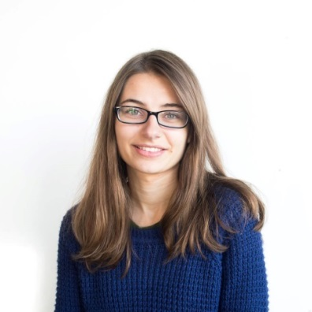

Madeline Molnor Milwaukee School of Engineering Civil Engineering—Junior
I would like to thank the Ralph Modjeski Scholarship committee for selecting me as a recipient for the Ralph Modjeski Scholarship. I’m very busy with a rigorous course load while majoring in civil engineering and I am a member of the Women’s Volleyball team at the Milwaukee School of Engineering. Between school and volleyball I make time for ASCE and try to be involved as possible in my community. Being so busy can be stressful sometimes, so with the help of this scholarship some of that extra weight is lifted off of my shoulders. Once again, I am very thankful for this scholarship.

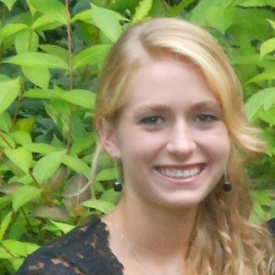

Piotr Wozny Iowa State University of Science and Technology –Mechanical Engineering Senior
Thank you for offering me the Ralph Modjeski Scholarship Fund, and I will accept this award. This means a lot to me, because it represents 2 key characteristics of who I am, a Polish American and an Engineer. I look forward to meeting yourself and the rest of the community on November 20th.

Szymon Krzeptowski Mucha--Illinois Institute of Technology Computer Science Junior

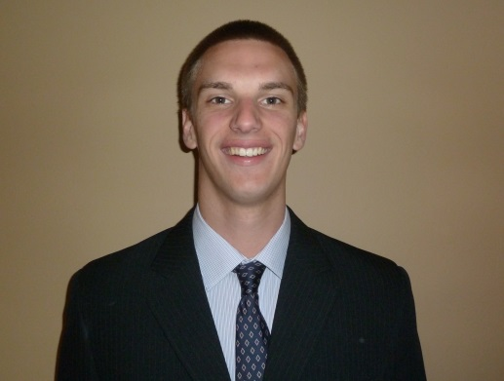r

>>>>>>>>>>>>>>>>>>>>>>>>>>>>>>>>>>>>>>>>>>>>>>>>>>>>>>>>>>>>>>>>>>>>>>>>>>>>>>>

The Chopin Theatre is inviting all members to a November 21st evening event. It will be a light dinner/show featuring the play by Slawomir Mrozek titled “Out at Sea.“ The cost is $25/person.

>>>>>>>>>>>>>>>>>>>>>>>>>>>>>>>>>>>>>>>>>>>>>>>>>>>>>>>>>>>>>>>>>>>>>>>>>>>>>>>

2015 MEMBERSHIP DUES. Please note that the dues schedule for 2016 has not changed. Dues are $50 per year, senior citizens and students $25 per year. We strongly encourage you to pay your dues at the January meeting. Membership cards will be provided to all those who paid their dues.
Questions? You may inquire at the meeting or send an email to: administration@polishengineers.org

You may send your dues directly to our Treasurer:

Mrs. Diana Kukawski
940 Beau Dr., Apt 209
Des Plaines IL 60016

Special Interest

The Polish American Congress Illinois Division is inviting our organization to the annual Heritage Awards Banquet scheduled for October 25th at House of White Eagle.

The Polish Museum of America invites all Members & Sympathizers of the PAEA to celebrate the 155th Anniversary of Ignacy Jan Paderewski Birth, in conjunction with the 2nd Ignacy Jan Paderewski International Festival.
The evening will begin on Saturday, November 21, 2015, at 5:30 pm at the PMA (984 N. Milwaukee Ave., Chicago, IL 60642), with a tour of the I.J. Paderewski Room; and include a concert performance by Marta Szlubowska, violin, and Svetlana Belsky, piano (6:30 pm); as well as a screening of the documentary film, “Paderewski: The Man of Action, Success and Fame,” directed by Wiesław Dąbrowski (7:30 pm).
Admission is $20, and $15 for PMA members (membership card required), seniors age 65 or older, and children 12 or younger. Light appetizers and desserts will be available, as well as a cash bar.

The Polish Museum of America invites all Members & Sympathizers of the PAEA to a Christmas Workshop, December 5th 10:00am – 12:00pm. For details please see the PMA website:

www.polishmuseumofamerica.org

www.polishengineers.org

